openSuSE Linux installation with software RAID
by Joey Kelly, 7/21/2034

Please note that we will be using software RAID. If you have a pair of hard drives in your computer, turn off hardware RAID in the BIOS before beginning this install.

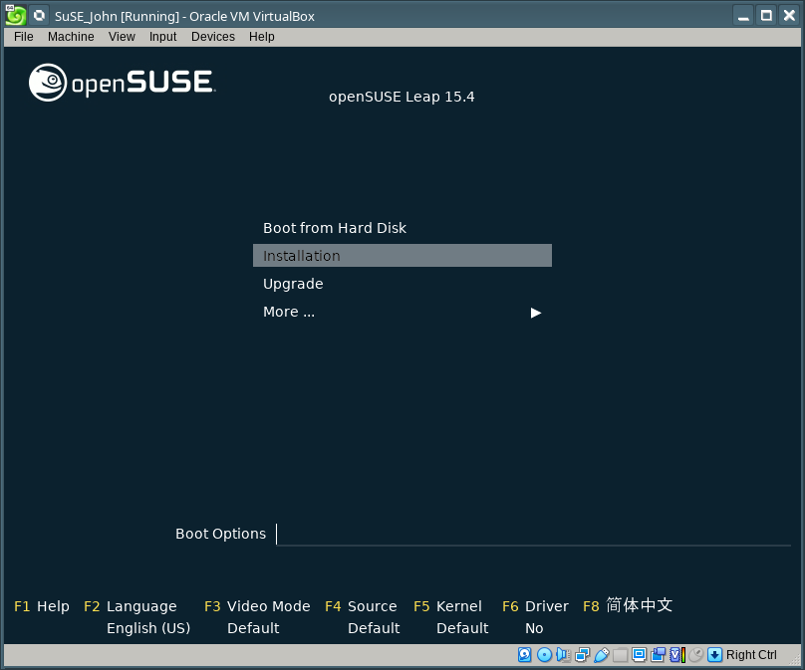

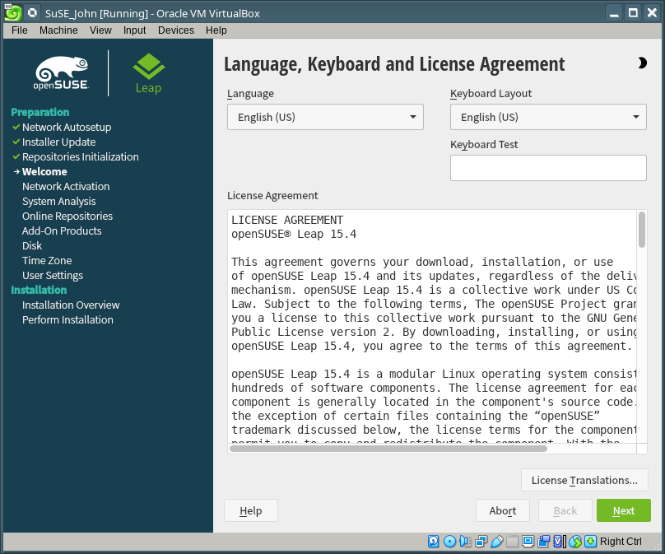

You’ll want to enable the online repos:

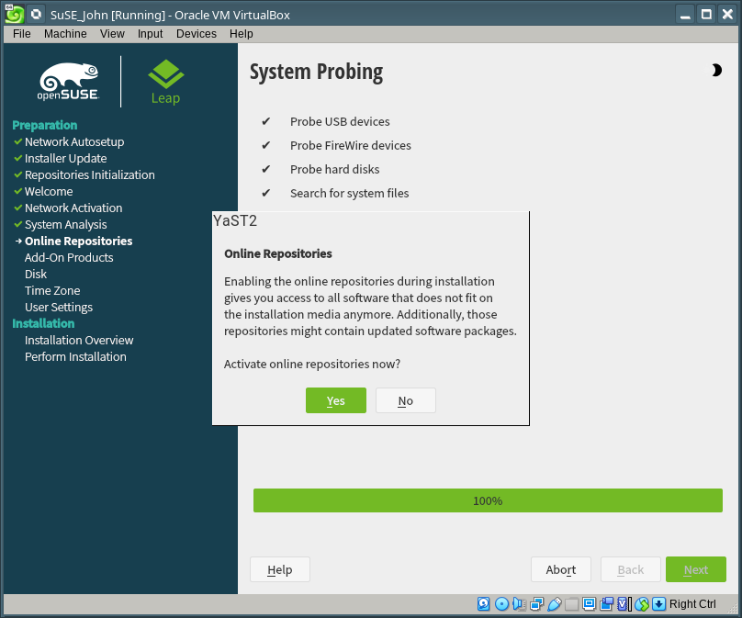

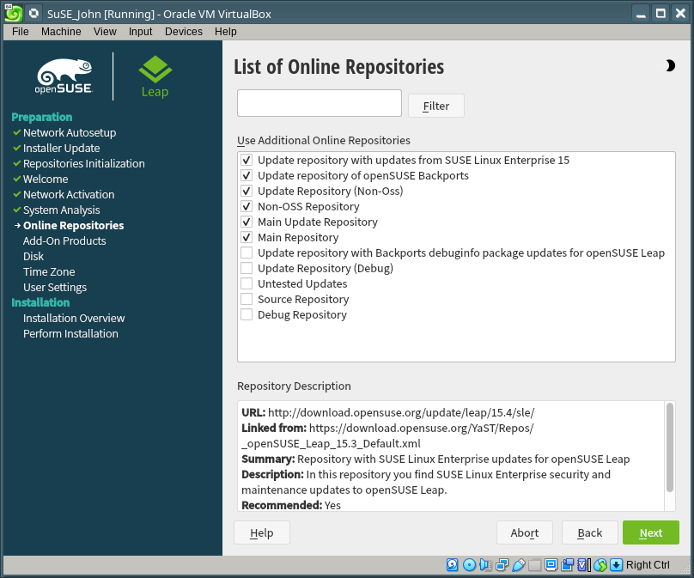

Choose Server role:

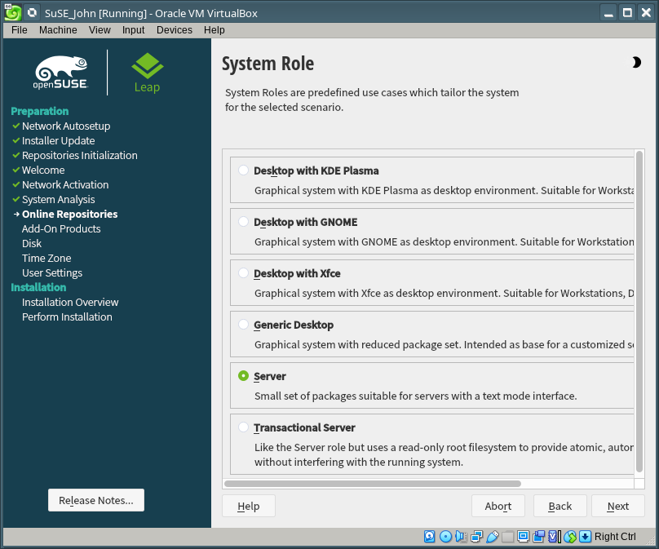

Time to partition your hard drives. We want RAID 1 (we’re using a mirrored pair of 2TB drives). Hardware RAID is turned OFF in the BIOS, and we’ll use Linux software to handle the RAID.

You want to choose “Start with Existing Partitions” here:

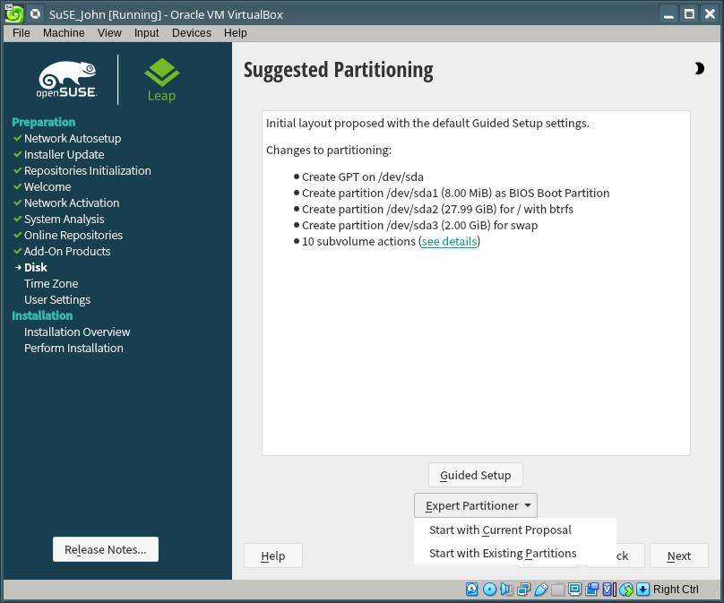

Choose RAID here, then click “Add RAID”

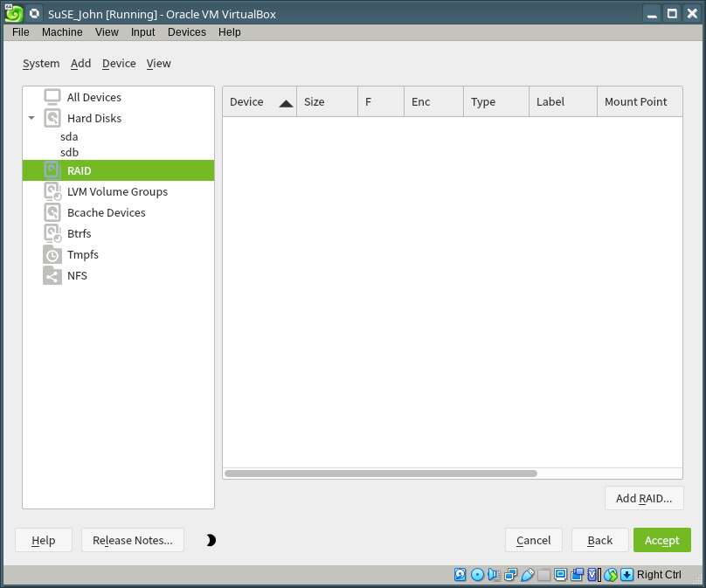

Select “RAID 1 (Mirroring)”, then click “Add All:

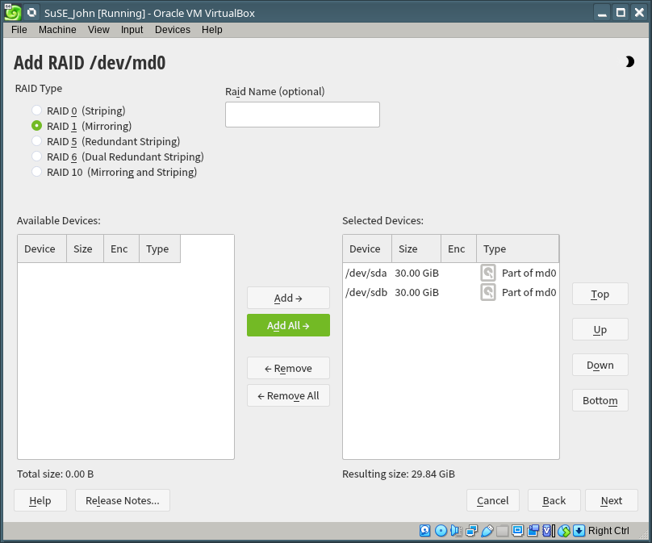

Choose the Chunk Size it offers you, if it’s offered:

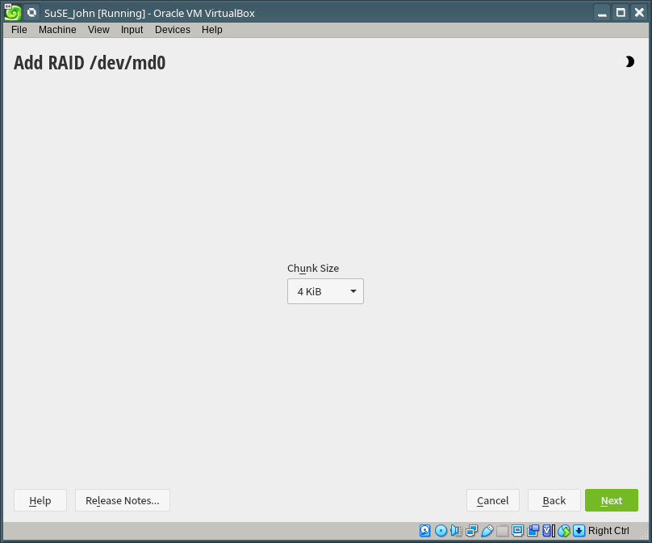

We have to add partitions next.

We need 4 partitions, one BIOS, one SWAP, one for /var and one for the root partition. Click “Add Partition”:

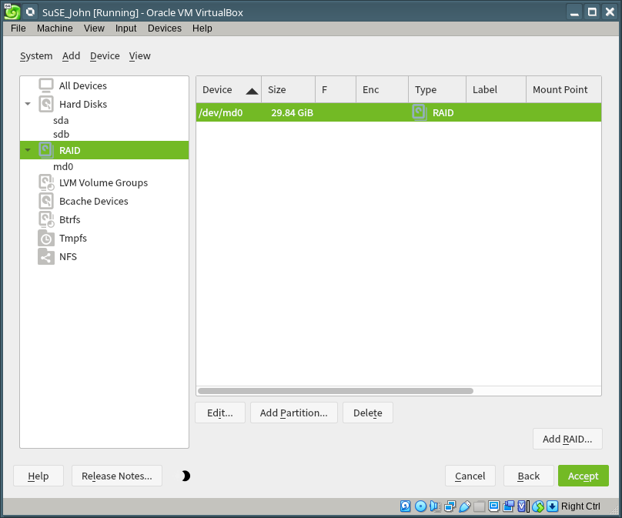

The BIOS partition doesn’t need to be big… 8MB is recommended.

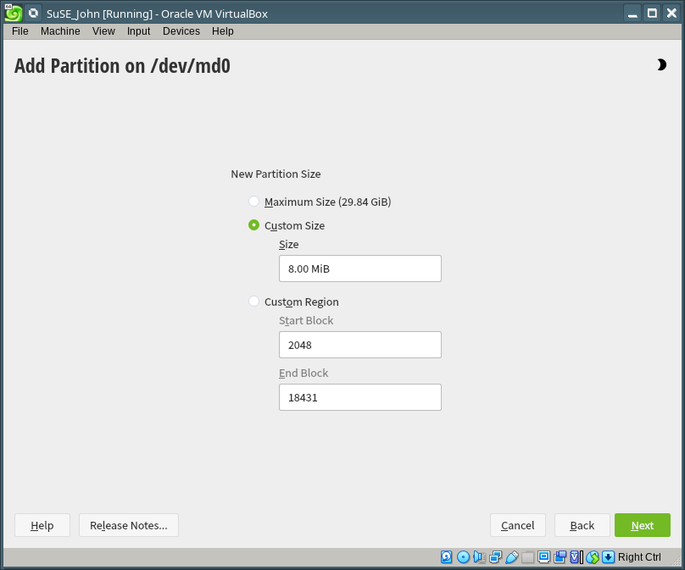

Choose RAW VOLUME here, and do not format it.

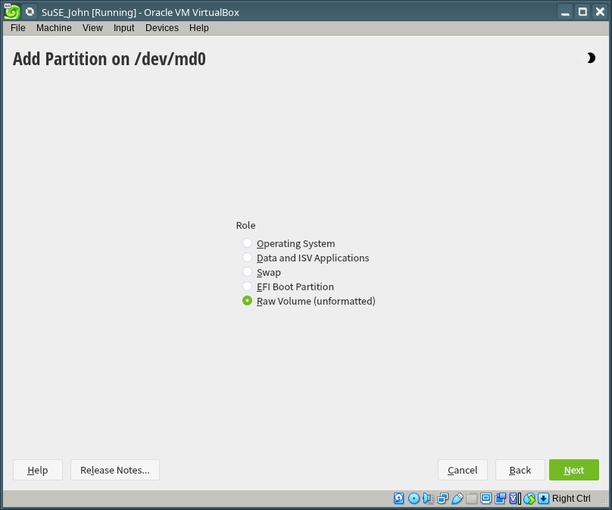

Choose BIOS Boot Partition:

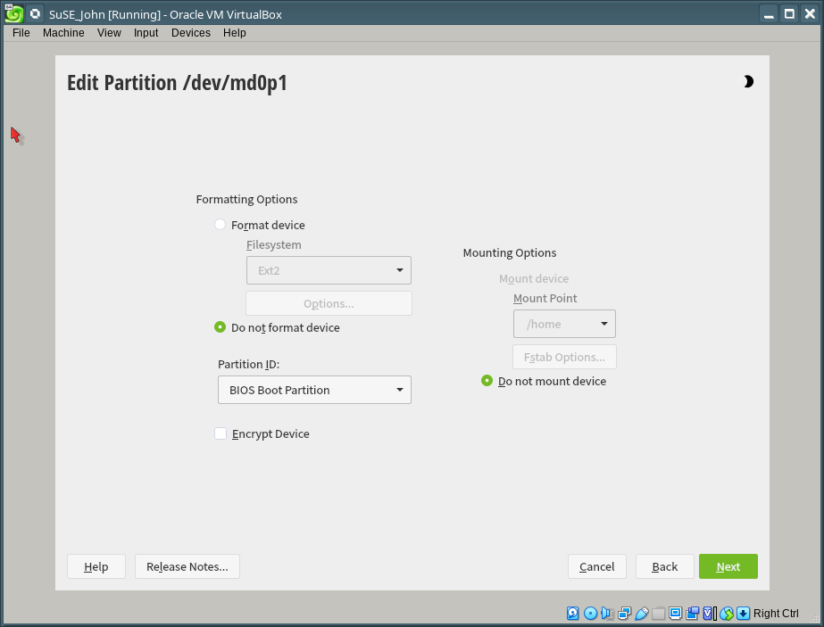

Add the second partition for SWAP (choose 16GB here):

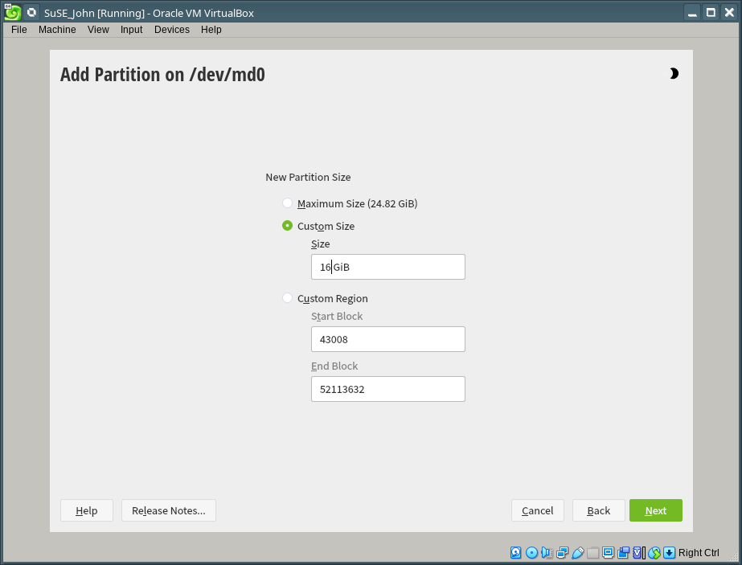

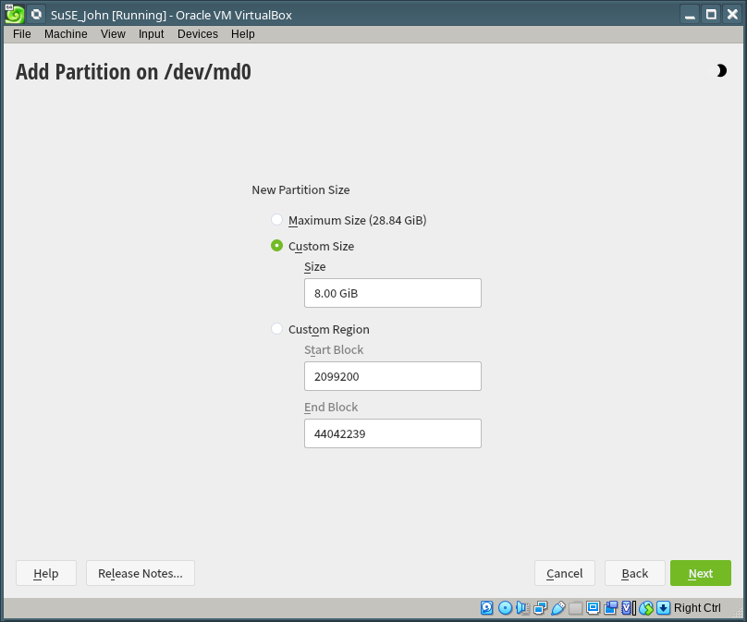
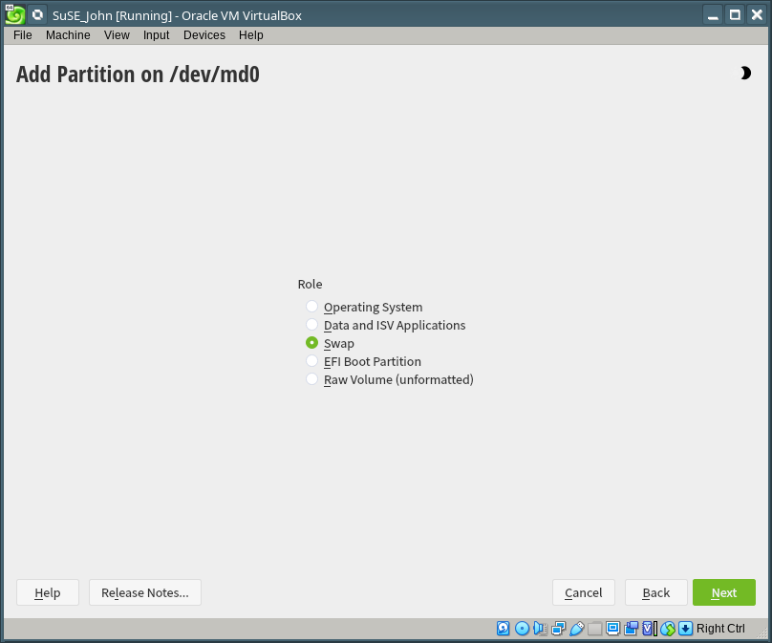

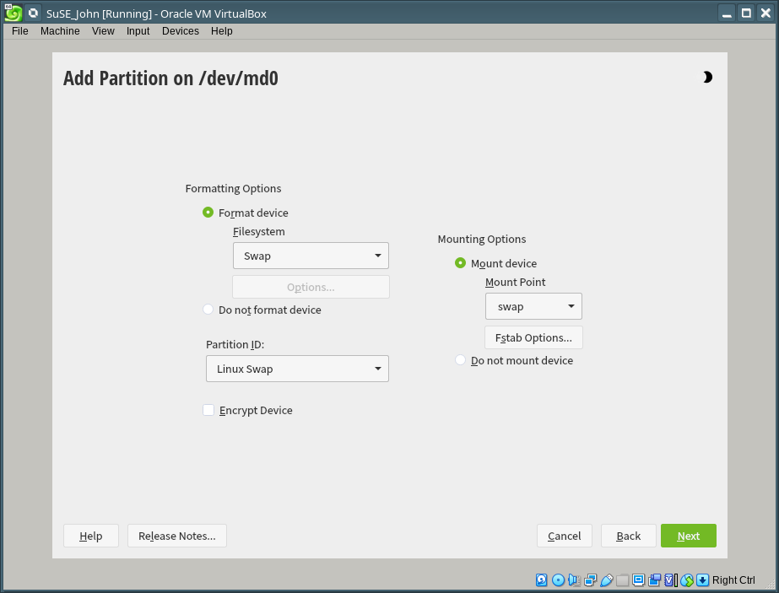

The third partition is for /var (choose 15GB here):

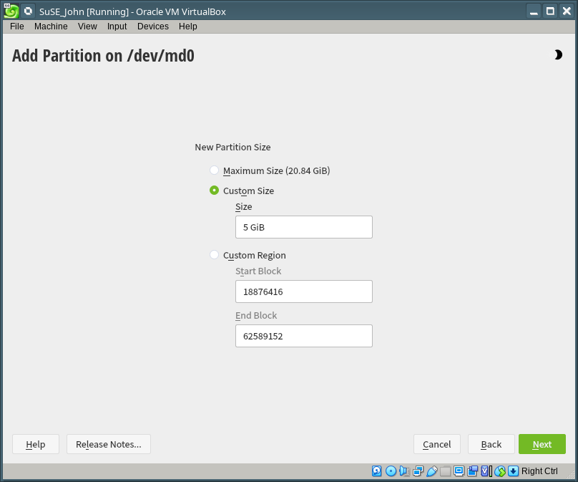

Choose Data and ISV Applications for disk role:

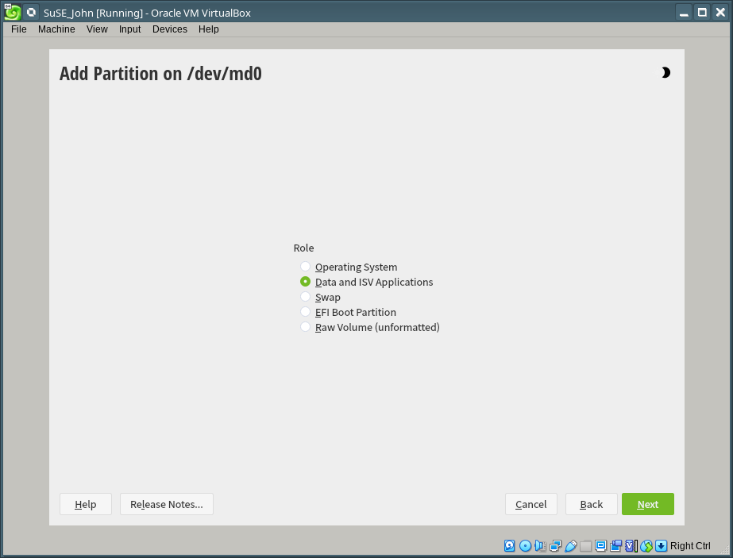

Select filesystem type EXT4 and mount point /var

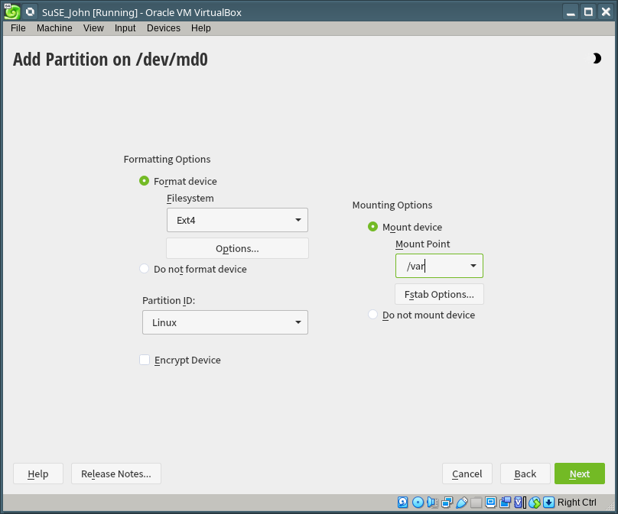

The final partition is for / (use all remaining hard drive space, with EXT4 filesystem):

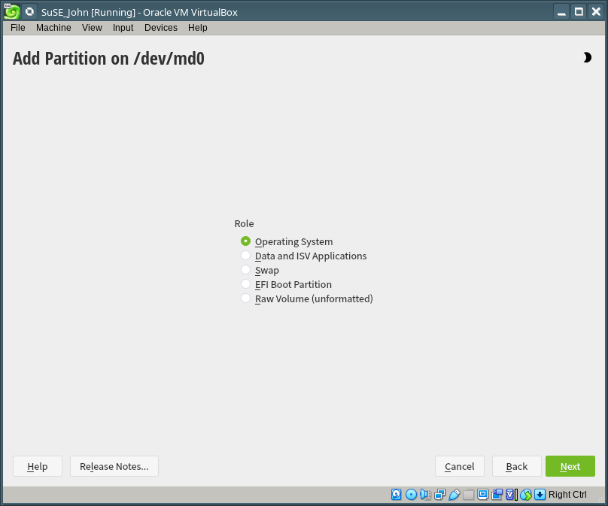
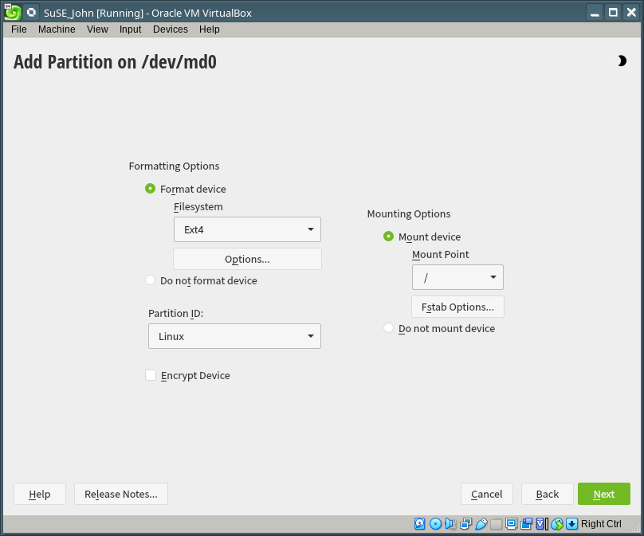

Here is what my partitions look like (your sizes will be bigger, I’m doing this on a small HD):

Finished adding partitions? Click “Accept”, then “Next”:

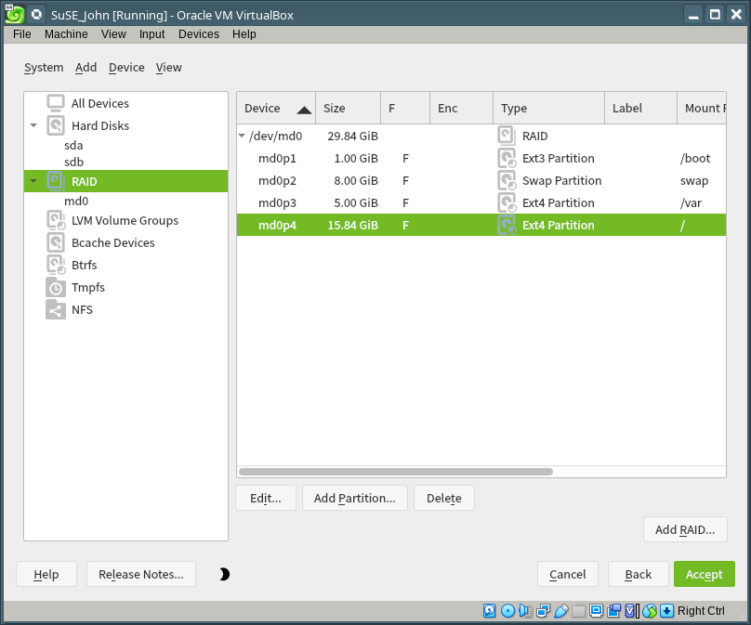

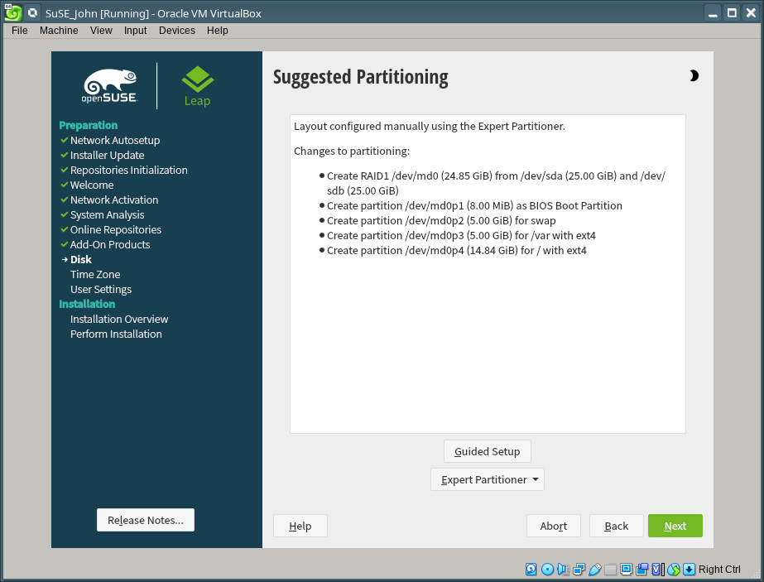

Partitioning done! Let’s move on

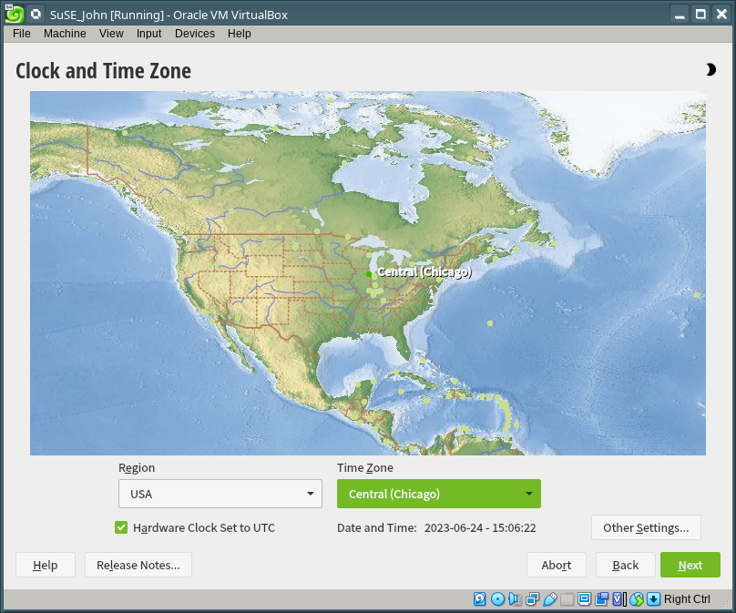

Create your user account, then click “Install”:

Click to start the install, then confirm your selection:

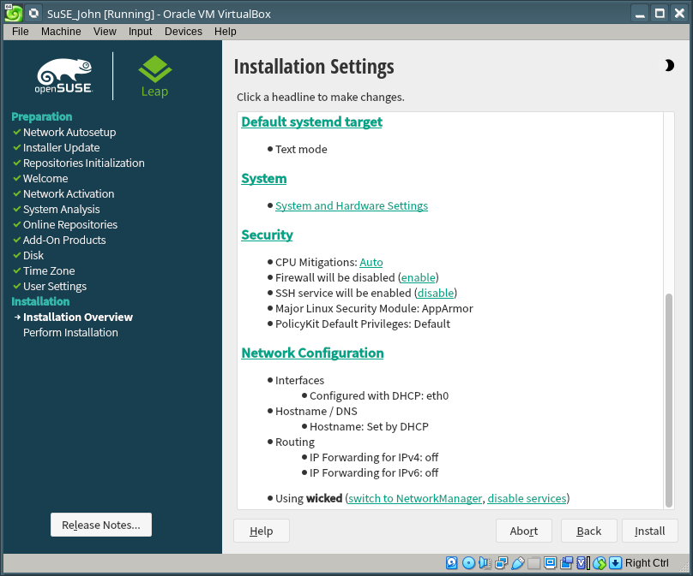

Random software installation failures (please make a note or snap a picture of each one). Hit “Retry” to see if the error clears up before hitting “Ignore”).

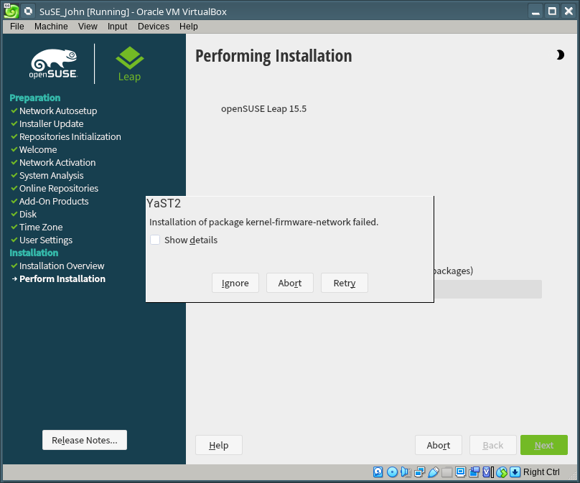

If all goes well, the system will reboot, time out and boot to the new Linux installation. You can log in, then remove the DVD from the drive.

Be happy.

