The 7 Seals

Revelation 4:1 Brings us in the presence of the Lord and Savior Jesus Christ.

"After This." This is better interpreted, "After these things." What things? It means after the Church age. When Jesus comes to calls His Church out of the world, the Church age ceases, as the Church will be with Jesus. We will not be caught up until the Church age is completed, the rapture will mark the end of the Church age, and it will be only at a time He knows. Matthew 25:13

"I Looked, And Behold." The word "behold" means "look." John is simply saying, "Look," when he saw what God had prepared for us. John was like a child in a circus when he saw all that was ahead for himself.

First Seal:

1: The Antichrist, the great deceiver appears on the scene riding on a white horse to conquer the world. We know this is the antichrist when we compare this to other scripture that tells us that the man of sin will come to power as a terrible world dictator immediately after the Church is caught up. This figure is Satan in the form of a man, he is the devil's key figure in the Great Tribulation. Read II Thessalonians 2.

He come riding on a white horse, an impostor of Jesus Christ. Other scripture passages tells us that he comes as a false messiah. He comes as Jesus will eventually come-- on a white horse.

Verse 3, 4:
Second Seal:

The Second Seal is open. What is it? It is WAR. Remember now that the Church has already been raptured away and the Antichrist is reviled, now comes bloody war.

Verses 5,6:
The Third Seal:

With the third seal comes famine.
A measure of wheat is approximately one quart. A "penny" was the normal day's wage for a laborer. Imagine a day's wage only buying a quart of wheat. The depression from the late 20's to 30's will be nothing compared the the hardships and trails people will have to endure during this awful time of tribulation. I thank the Lord that I'll be in the presence of the Lamb at the marriage supper of the Lamb, enjoying a wondrous feast with fellow born again Christians while this is happening.

"See thou hurt not the oil and the wine." Oil and wine in the Bible always tend to symbolize luxury. There will be none in that day for the commoners, the world shall be cast into a terrible time of hunger and economic collapse.

Verse 7, 8
The Fourth Seal:

The Fourth Seal is open, it brings forth death.
"One fourth part of the earth" simply implies that one fourth of the earth will be killed. Imagine that, the worlds population is approximately 6 billion people, that simply means that at this point, 1.5 billion people will be killed. That many lives will be killed in such a short period of time.

verses 9, 10, 11:

These verse deal with the souls of the martyrs. The question comes to immediately as to what martyrs? They could not be the souls of the martyrs slain before the rapture, they were raptured and they received their glorified body in Revelation Chapter 4. Hence, these must be the ones who are killed for the Gospel during the tribulation up to this time. In verse 8, one fourth of the world's population was killed, and probably, many of these were martyrs. I believe that God's world endureth forever, it is his promise to us that it will, I believe that there will be some who art not saved and see this as an act of God, and accept His son as Savior, I believe that the Bible will be picked up by some in this day, and will accept Jesus as Savior, and may even find tracts on Salvation.
Please notice that they are killed for the Word of God and the testimony which they held. They are under the alter. Why an alter? The answer is simple. The brazen alter was the place of sacrifice. Every person who dies for Jesus gives the supreme sacrifice.
There are several things that are taught here about souls that should be brought out in this study.
(1.) The dead in Christ are still alive.
(2.) They can be seen. John said that he saw them.
(3.) They are with Jesus.
Notice their cry, "How Long?" They are so anxious to gain their glorified bodies. "Even so, come, Lord Jesus."

The Sinner's prayer meeting ... Revelation 6:12-17.

Verse 12:
Here we have the opening of the 6th seal.
"There was a great earthquake." The word here for "earthquake" means "quaking in general." In other words, there shall be quaking all over the earth. It also means to "shake, toss, or jolt." It involves the entire world and planetary system in a time of commotion.
"And the sun became black." Imagine sleeping until noon and it is still dark outside. Imagine it with the sun completely darkened. Such a day took place in May, 1870. People were in a state of panic as the day became dark for seemingly no reason at all.

Verse 13:
Imagine, the stars of heaven falling upon the earth, perhaps a commit coming toward the earth exploding over out atmosphere, as was the case in Siberia in 1907, more than 750 miles of trees were scorched. Imagine, great fiery balls being cast down to the earth, perhaps setting great cities on fire, and a great loss of life. On November 12th, 1833, a shower of shooting stars were seen in most parts of North America, cities were emptied immediately, men, women, and children running in terror for great beds of water, in fear that the shooting stars were from God and that they would kill and destroy the great cities of that day. But these stars fall upon the earth, and will, without doubt, cause many deaths, and much pain.

Verse 14:
You have seen a scroll unroll and roll up. That is what is ment here.
The reason for the mountains moving is simple. Several times in California there has been a quake so bad in California, that rivers have dried up as a result, and mountains even moved, and hills and small mountains leveled. That is exactly what will happen here. Just imagine how morbid everything will look.

Prayer meeting:

The Prayers.
(1.) Kings-- who thought they were too powerful for Jesus
(2.) Great men-- who thought who thought they were too great for God.
(3.) Rich men-- who thought they were too wealthy for God.
(4.) Soldiers-- who thought they were too strong for God.
(5.) All rejecters of Christ.
They reject the Rock of Ages, they now pray for the rocks of the mountains.

Notice their prayers, "Hide Us." They were asking to be hidden from Jesus, when they could have been hiding in Jesus. And well they might cry for a hiding place from Jesus, for He will pour out His wrath upon them.

Chapter 7:
This chapter deals with those who will be saved during the tribulation:
Verse 1 :The Four Winds in this verse can be explained by Ephesians 2:2 and Daniel 7:2. These winds are the wrath that is going to be unloosed by Stan who is the prince of the power of the air.

Verse 2, 3:
Just before the trumpets of judgment are turned loose, an angel comes from the sun rising and delays them for a while in order for the servants of God to be sealed.
Once again, God protects His own.

Verse 4:
Who are those that shall be saved? They are the 144,000 Jews, God is not through with His chosen race, the Jews. They are returning everyday to their land. Some are to be there to make a covenant with the Antichrist, we believe from Daniel 9:27.
How will they get the Gospel? After the rapture, there will still be Bibles here, as well as tracts, etc. These will probably be used by the Lord to reach the lost House of Israel.
What is their work? They will be the ones who will spread the gospel to all the world during the tribulation. These 144,000 preach that Jesus Christ is the Messiah.

Verse 5-8:
The meanings of the names of the twelve tribes are interesting. Notice the following:

1. Judan.....................................................................Praises of God
2. Reuben............................................................Looking to the Son
3. Gad............................................................................A company of
4. Aser............................................................................Blessed ones
5. Nepthaim.................................................................Wrestling with
6. Manasses....................................................................Forgetfulness
7. Simeon.............................................................Hearing and obeying
8. Levi....................................................................................Cleving to
9. Issachar................................................................................A reward
10. Zabulo ................................................A home and dwelling place
11. Joseph....................................................................................Adding
12. Benjamin ...................................................Sons at God's right hand

Read down the list of meanings and you'll find the purpose of the Jews. They are praisers of God looking to the Son, a company of blessed ones wrestling with forgetfulness, hearing and obeying and cleaving to a reward of a home and a dwelling place, adding sons at God's right hand.
Those saved during the tribulation: Not only will there be 144,000 Jews saved during the tribulation, but there will be people of every nation under the sun saved.
Verses 9-17 deal with converts:

Verses 9, 10:
Imagine the beauty of this occasion-people from every nations under heaven singing together (The saved).
Notice that they have palms in their hands. This came from the Old Testament Feast of the Trumpets when the people, after harvest, carried palm leaves in their hands and worshipped God in booths as a time of rejoicing, hence, these saints are rejoicing because of their Salvation.

Verses 11, 12:
At such an impressive scene as this, the angels join in singing in a time of real rejoicing. This is in accord with Luke 15;10. The angels always rejoice when a soul comes to Jesus.

Verses 13, 14
Notice that these verses tell who these are who are saved. They came out of great tribulation. More along the lines, The Great Tribulation.

Chapter 8:

Thus far, we have seen the opening of six of the seven seals. The seal contain punishment man shall bring
upon himself. The trumpets contain the judgments God will inflict upon man. The seventh seal contains the seven trumpets, as in the following illustration:

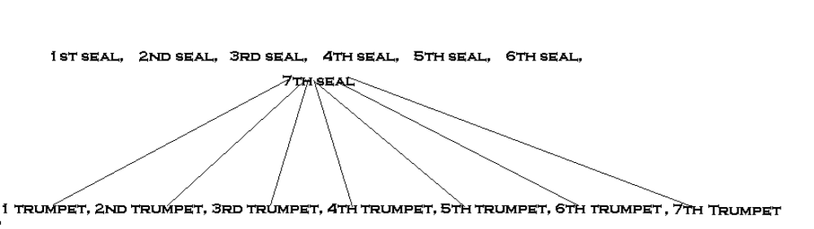

In other words, the seven trumpets are in the seventh seal.

Verse 1:
For several chapters now we have been hearing the choirs rejoice. As we come to verse 8, these choirs suddenly stop. This is a large choir that comes to an immediate halt. The four living creatures, the hundreds of millions of angels, the saints of all the ages, suddenly stop their singing.
Why does the singing and rejoicing stop? Simply because the most horrible things that will ever happen are about to happen as the trumpets blow. The silence is like a breathless gasp for about a half an hour, and all the choirs of Heaven gasp in horror as they stop for a breathless moment of silence.

Verse

